**Experiment -4**

**Exper 4 :- How to Install Desktop Docker?**

**Go to google and type Docker Hub**

Step 1:- Double-click **Docker Desktop Installer.exe** to run the installer.

Step 2:- When prompted, ensure the **Use WSL 2 instead of Hyper-V** option on the Configuration page is selected or not depending on your choice of backend.

Step 3:- Follow the instructions on the installation wizard to authorize the installer and proceed with the install.

Step 4:- When the installation is successful, click **Close** to complete the installation process.

Step 5:- If your admin account is different to your user account, you must add the user to the **docker-users** group. Run **Computer Management** as an **administrator** and navigate to **Local Users and Groups** > **Groups** > **docker-users**. Right-click to add the user to the group. Log out and log back in for the changes to take effect.

## 

## How to Start Docker Desktop

Docker Desktop does not start automatically after installation. To start Docker Desktop:

1. Search for Docker, and select **Docker Desktop** in the search results.

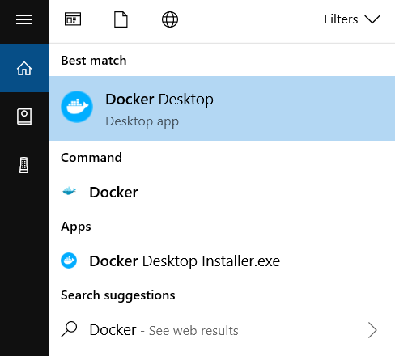

Step 2:- Select **Accept** to continue. Docker Desktop starts after you accept the terms.

1. **How to find Docker images?**

### WHAT YOU NEED TO KNOW

* To run an application in Docker, it needs to be formatted as a **Docker image**
* Images for Docker are usually stored in a **registry**
* The most popular public registry is **Docker Hub**
* You can use a web browser, or **docker search <query>**, to search for an image in Docker Hub

## How do I search for Docker images?

1. Visit **Docker Hub** at [hub.docker.com](https://hub.docker.com/) in your web browser.
2. Click **Explore** to view all images, or **enter a search query** to find images:

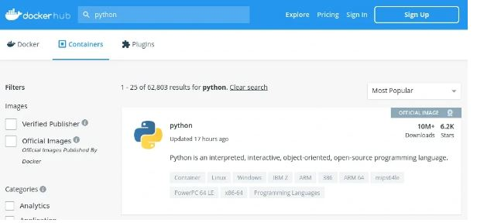

1. Click on a result to see the image details:

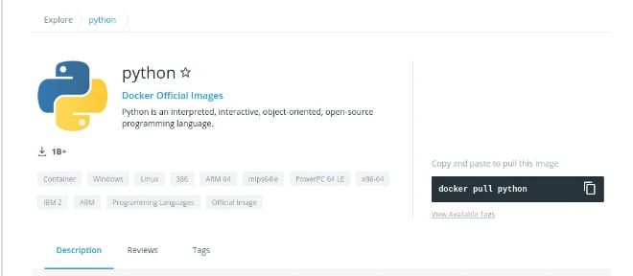

The **tags** Tab will show you all of the different tags within that image, which you can pull and run with Docker.